DSP PLL 87-108MHz Stereo FM Transmitter Module Digital Wireless Microphone Board Multi-function Frequency Modulation

Product Introduction;
1.Output Power:100mW
2.Audio Frequency Response Range:50Hz-18KHz
3.Transmission Frequency:87.0MHz-108.0MHz (campus broadcast power off);76.0MHz-108.0MHz (campus broadcast power on)
4.Frequency Adjustment Stepping:0.1MHz/times (short press the key);1.0MHz/times (long press the key)
5.Modulation Mode:standard FM
6.Sound Track:LINE/USB channel (stereo);MIC channel (single channel)
7.Equivalent Noise:>=30dB
8.Power Supply Voltage:DC 3.0V-5.0V
9.Operating Current:35mA
10.Adaptive Antenna:75cm bar antenna
Application:
1.FM Wireless Frequency
2.USB PC Audio Broadcast
3.Wireless Microphone
4.Maternal And Infants Custody
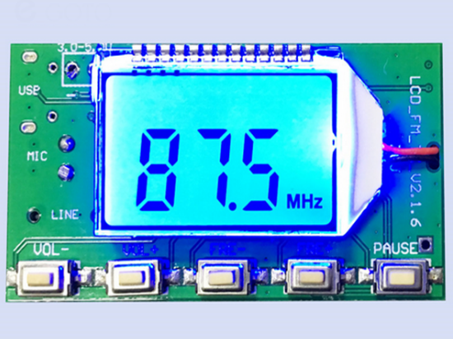
一、Product characteristics:

1: the use of advanced digital audio signal processing technology (DSP) and FM phase-locked loop modulation technology (PLL) make the sound quality more realistic, the performance is more stable, and the long working frequency has no offset.

2:The LCD display is more intuitive and accurate, with very low power consumption and minimal noise interference.

3: has a built-in 30 level digital volume adjustment, and the key operation can be done easily.

4: the data before the power off is automatically remembered.

5: multi source input automatic switching

6: quartz crystal frequency stabilization, temperature changing the emission frequency no longer drift

7: support serial command control

二、Product parameters:

Output power: 100mW

Audio frequency range: 50Hz-18KHz

Emission frequency:

Turn off the campus radio 87.0MHz-108.0MHz and open the campus radio 76.0MHz-108.0MHz

Frequency adjustment step: 0.1MHz/ times (press short press), 1.0MHz/ times (press long press press)

Modulation mode: Standard FM FM

Channel: LINE/USB channel (stereo), MIC channel (Single channel)

Equivalent noise: more than 30dB (close to CD sound quality)

Power supply voltage: DC 3.0V-5.0V

Working current: 35mA

Transmitting antenna: 75cm pull rod antenna

Transmission distance: FM transmitter module is connected to the 75cm standard antenna and radio Tecsun PL-660, open field covering a radius of 100 meters. (Note: the distance of the launch is only for reference, because there is a slight difference in the use of the environment)
三、the scope of application:
FM wireless audio, USB PC audio broadcast, wireless microphone, mother and baby monitoring.
Module connection instructions (please sign the wiring strictly according to the following chart):
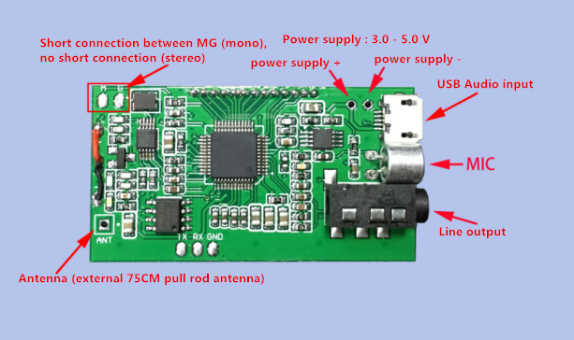
Key function arrangement:
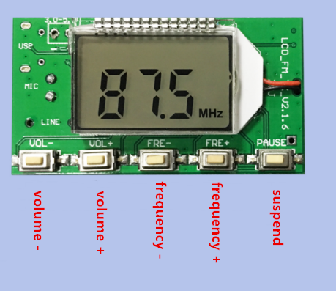
四、 Use of instructions:
<1>: power supply
The modules correspond to the ports - the negative and positive poles of the power supply (battery), and the power is recommended for batteries or other power supply. We can't use switch power without filter, such as mobile charger and other low-voltage switching power supply, otherwise the interference generated by power will affect the normal operation of this module. The normal operating voltage of this module is 3.0-5.0V, and the supply voltage should not be paid more attention than this range.
<2>: Keys
Volume: short press the volume + + / - 1, press the + / - continuous
Frequency: short press + / - frequency + / - 0.1MHZ, press 1MHZ + / - continuous
Mute: short switch mute / non silent
<3>: Antenna
The ANT port is used to connect the FM antenna. In order to better transmit the FM signal, it is recommended to externally connect the 75cm length rod antenna, and there will be no obstacle as far as possible near the antenna.
<4>:USB audio connection
If you need the USB audio broadcast function of this module, you also need to connect to the USB line connection computer. The USB port is compatible with the ordinary mobile phone, so the USB line of the mobile phone can be used to connect the module and the computer. Because the computer USB with 5V output, so the use of USB connection computer can directly use the USB port to provide power for the module. Connected to the computer USB, this module will automatically enter the PC audio broadcast mode, the LCD screen will display PC, the client computer will automatically install the driver, and give the module named "CD002" sound equipment, settings enabled and enable the "CD002" audio equipment in computer voice, computer audio system you can through this module to transmit FM FM, radio frequency adjustment to the nearby and transmitting module can listen to audio frequency system of the computer terminal module launch.
<5>:LINE audio connection
If you need this module LINE (line input) channel as audio emission, only the audio line end is inserted into the module 3.5mm audio jack, the other end is inserted into your audio device (such as mobile phone headset, the hole) module automatically switches to the LINE channel for FM emission source. The nearby FM radio can hear the audio from the mobile terminal as long as it is adjusted to the frequency of this module.
<6>:FM wireless microphone
If you need this module MIC as a source of sound emission, just unplug the LINE line and USB line (i.e., LINE and USB are not connected), the module automatically transferred to the MIC channel as the emission source of FM, this module with high sensitivity of the electret microphone, can be used in wireless microphone, maternal and child care. In use, we should pay attention to adjusting the volume of this module to achieve the best sound pickup effect.
<7>: serial port control (no need to control this part without serial port control)
Module set aside TTL level serial port control interface, TTL serial port to communicate with this module needs UART_RX of connection module, UART_TX and GND, can use external MCU (MCU) or computer serial port to send command control module related functions. Note: because the serial port level of the computer is not TTL level, when connecting to the computer communication, it is necessary to connect RS323 level to TTL level switching device or to communicate with the module with USB TTL level serial module. Because the serial command control module needs certain computer expertise, the buyers who do not understand need not toss. All the information shows baby shows that customer service does not provide technical guidance in this area.
User custom settings:
1: setting of backlight LED mode
Power-off state at the same time long press, radio button, display B1 backlight B0 backlight lit, 20 seconds off, restart the settings to take effect. (the factory default is set to backlight 20 seconds delay off).
2: opening / closing the campus radio frequency band
Power-off state long press VOL+, VOL- key power on LCD C1 said C0 said off campus campus radio broadcast band, after the restart to take effect. (the factory is set up to close the campus broadcast frequency band by default).
3: stereophonic / mono channel emission mode setting
Module on the back of two solder joints M, G between two points short circuit for the mono mode emission, two continuous open stereo emission standard. (the factory by default is a stereophonic launch). Note: the sound source of the stereo must satisfy the sound source of the input to the module, and the radio is also stereo only to achieve the stereophonic effect. (don't take a single trumpet (single channel) radio or input a module's audio signal to a single channel that there is no stereophonic effect!!!!).
五、 Note:

1: the power supply voltage is strictly forbidden to exceed the power supply voltage range of this module.

2: can not touch the back component of the module when working, so as not to affect the normal work of this module or cause the short circuit destruction module.

六、user settings:

This module can set the backlight state and listen to the campus broadcast frequency band according to the user's specific usage, and the setting method is as follows. In the state of power off, a long press of VOL+, VOL- button on the LCD display C1 indicates that the campus broadcast C0 shows the closing of the campus radio frequency band, and the reset setting is effective. When setting up the backlight state, the button will turn on at the same time when the power is down. The B1 will indicate that the backlight is always bright. B0 means backlight for 20 seconds to close. After reset, the settings will take effect. Change the state of the setting to repeat this step. The factory is set to unopen the campus broadcast frequency band, the backlight is not operated for 20 seconds to go out.

